H.T No
Regulations:
A17

Sreenidhi Institute of Science and Technology
(An Autonomous Institution)
Code No: 6E517 Date: 15-July-2023 (FN)

B.Tech III-Year II- Semester External Examination, July - 2023 (Supplementary)
THEORY OF COMPUTATION (CSE)

Time: 3 Hours Max.Marks:75

Note: a) No additional answer sheets will be provided.
b) All sub-parts of a question must be answered at one place only, otherwise it will not be valued.
c) Missing data can be assumed suitably.

Bloom's Cognitive Levels of Learning (BCLL)

Remember | L1 | Apply | L3 | Evaluate | L5
Understand | L2 | Analyze | L4 | Create | L6

Part - A Max.Marks:25
Answer all QUESTIONS

 |  | BCLL | CO(s) | Marks
1 | Define (i) String (ii) Alphabet (iii) Language | L1 | CO1 | [2M]
2 | Illustrate FA with outputs. | L2 | CO2 | [2M]
3 | Define Grammar and Derivation with example. | L1 | CO3 | [2M]
4 | What is ambiguous grammar explain with an example | L3 | CO4 | [2M]
5 | Define Church's Hypothesis. | L2 | CO5 | [2M]
6 | Define (i) Closure (ii) Powerset | L1 | CO6 | [3M]
7 | Sketch and explain in detail the model of FA. Give its tuple notation. | L2 | CO1 | [3M]
8 | Define parse Tree with Example? | L1 | CO3 | [3M]
9 | List the enumeration properties of Context Free Languages | L2 | CO5 | [3M]
10 | Define Post correspondence Problem | L1 | CO6 | [3M]
Part – B Max.Marks:50
ANSWER ANY FIVE QUESTIONS. EACH QUESTION CARRIES 10 MARKS.

 |  |  | BCLL | CO(s) | Marks
11. | a) | Draw Transition diagram for the Transition table given below and check acceptance for the strings: i) 1000101 ii) 011001  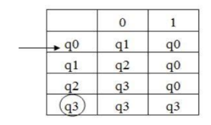 | L4 | CO1 | [5M]
 | b) | Design a DFA to accept the following language. L = {w: |w| mod 3 = 0} on Σ = {a} | L3 | CO1 | [5M]
12. | a) | Define ε-closure. Find the ε-closures of each state in the following ε- NFA.  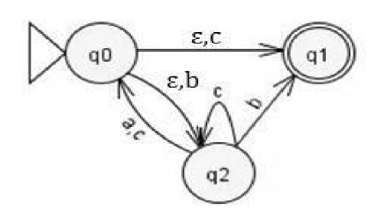 | L4 | CO2 | [5M]
 | b) | Design a Moore machine to determine the residue mod 4 for each binary string treated as integers. | L3 | CO2 | [5M]
13. | a) | Construct a deterministic finite automaton equivalent to the grammar S-->aS|bS|aA, A-->bB,B-->aC,C-->ε | L3 | CO3 | [5M]
 | b) | Define Ambiguous Grammar. Check whether the grammar. S→aAB,A→bC|cd,C→cd,B→c|d Is Ambiguous or not? | L4 | CO3 | [5M]
14. | a) | Convert the following CFG into GNF  S→ABa/a, A→aaA, B→bAb | L3 | CO4 | [5M]
 | b) | Construct PDA for language L={a^{n}b^{2n}|n>=1} | L3 | CO4 | [5M]
15. | a) | Illustrate various types of Turing Machines. | L2 | CO5 | [5M]
 | b) | Design a TM for subtraction of two numbers. | L4 | CO5 | [5M]
16. | a) | Discuss in brief about NP Hard problems | L2 | CO6 | [5M]
 | b) | Explain about the Decidability and Undecidability Problems. | L1 | CO6 | [5M]
17. | a) | Design NFA accepting the set of all strings that begins with “abb” over alphabet {a, b}. | L3 | CO1 | [4M]
 | b) | Construct a Mealy machine which is equivalent to the Moore machine given in table:  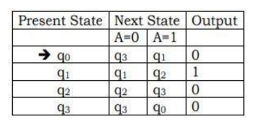 | L4 | CO2 | [3M]
 | c) | Construct a DFA to accept the language generated by the following grammar S-->01A,A-->10B,B-->0A|11 | L3 | CO3 | [3M]
18. | a) | Distinguish between PDA and DPDA | L2 | CO4 | [4M]
 | b) | Define Turing Machine. With a neat sketch explain the working of a Turing machine. | L2 | CO5 | [3M]
 | c) | Give an overview of recursively enumerable language | L2 | CO6 | [3M]

-- 00 -- 00 –

